06 If… Else

The circuit
Drawing pins
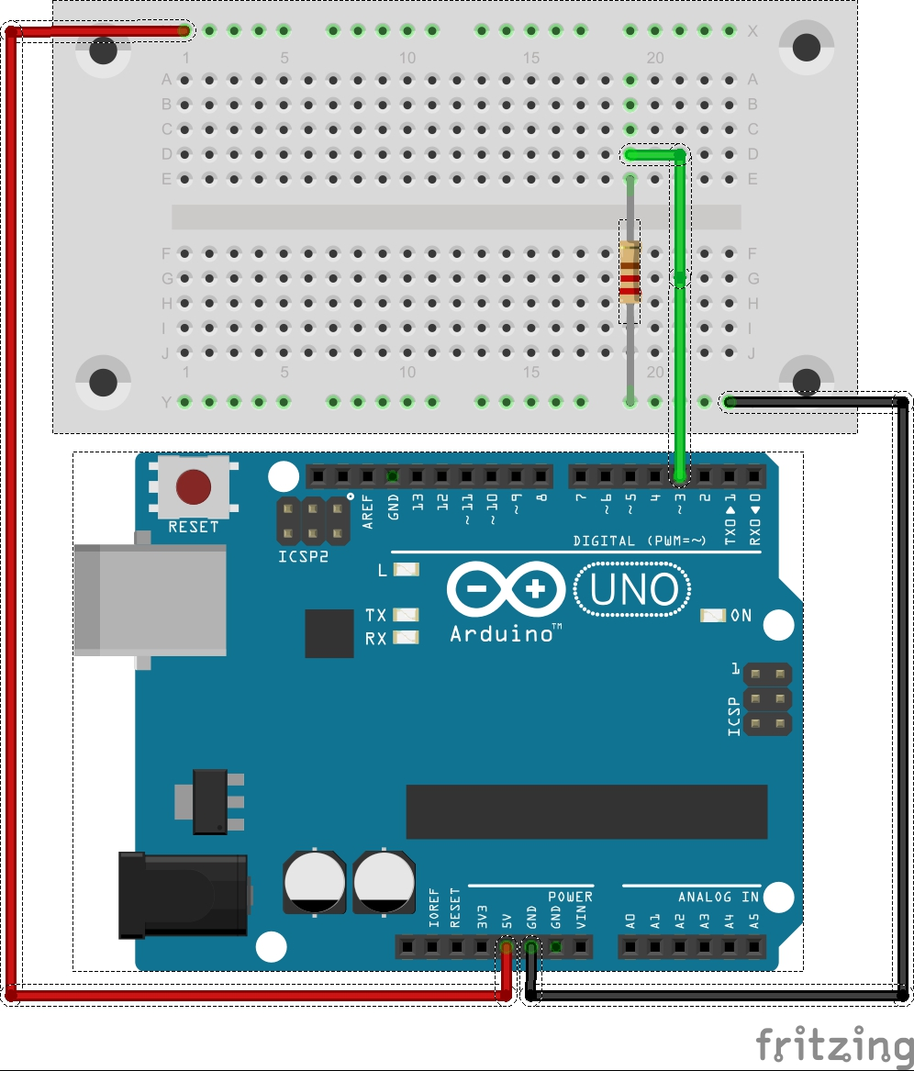

The code

void setup() {
pinMode(3, INPUT); //set pin 3 the input pin as input
pinMode(12, OUTPUT); //the speaker on pin 12 is an output
pinMode(13, OUTPUT); //the LED on pin 13 is an output
}//end of: setup

void loop() {
delay(100); //pause the program for 0.1 seconds

if(digitalRead(3)!=LOW){ //if pin 3 is not low (0 volts)
digitalWrite(13,HIGH); //turn on the LED attached to pin 13
tone(12, 240); //play a tone on pin 12
}
else{ //if pin 3 is low (0 volts0
digitalWrite(13,LOW); //turn off the LED on pin 13
noTone(12); //stop playing the tone on pin 12
}
}//end of: loop

What Next
- Find out what this comparisons do in the if statement brackets: digitalRead(3)==LOW

- Shift the green wire to an analog pin and analogRead() its value in and store it as an int variable (for example int analogValue = digitalRead(A0);)

- Compare the variable in your if statement brackets with these comparisons:

  - analogValue > 512
  - analogValue < 512
  - analogValue >= 512
  - analogValue <= 512

