07 For

The circuit

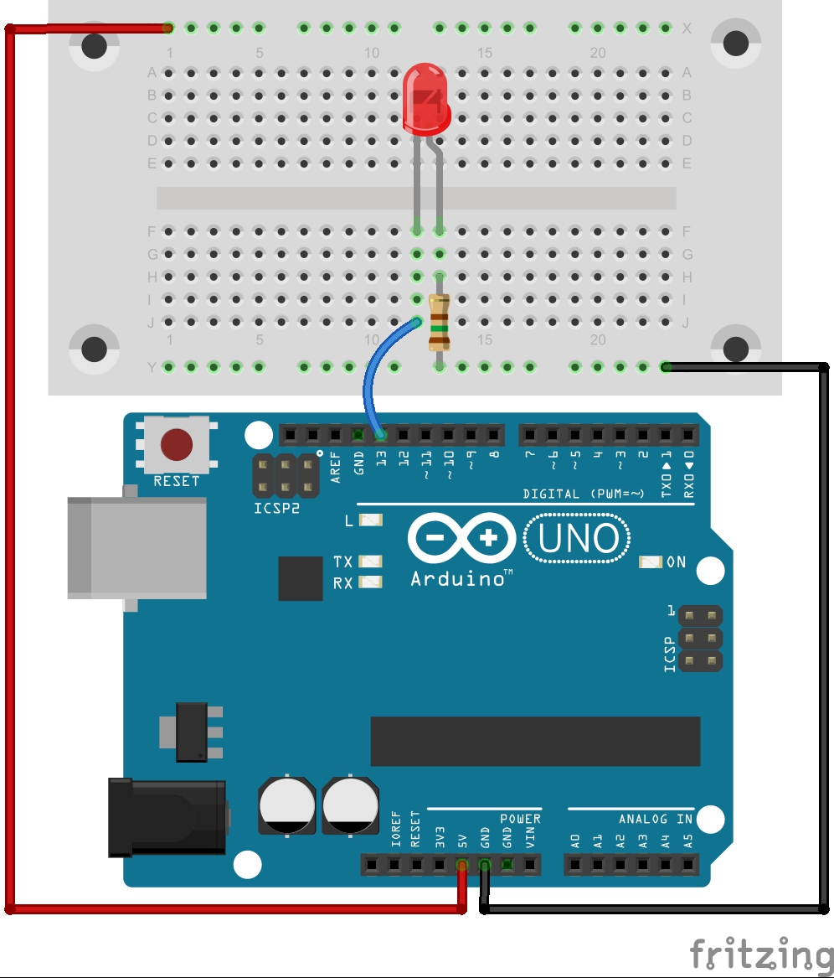

The code

// Dim an LED using a PWM pin
int LEDPin = 13; //variable storing the pin number the LED is connect to

void setup()
{
pinMode(LEDPin, OUTPUT); //Set the pin the button is attached to as an input
}//End of: setup

void loop()
{
//The for loop... the first value in the brackets is a initialisation
//an integer value, called i, that starts set equal to zero.
//The second part is the condition, the loop will keep repeating
//until the condition is not true. The final part is the increment,
//each time it loops through the value gets incremented by 1
for (int i=0; i <= 255; i++){
analogWrite(LEDPin, i); //Analog write the i value to the LEDPin
delay(10); //pause for 10 milliseconds
}
}//End of: loop

What Next
- Add another for loop after this one, so the LED slowly dims after it reaches full brightness
- Print the i value to the terminal inside the for loop so you can see it count up from 0 to 255

