01 Digital Write

The circuit

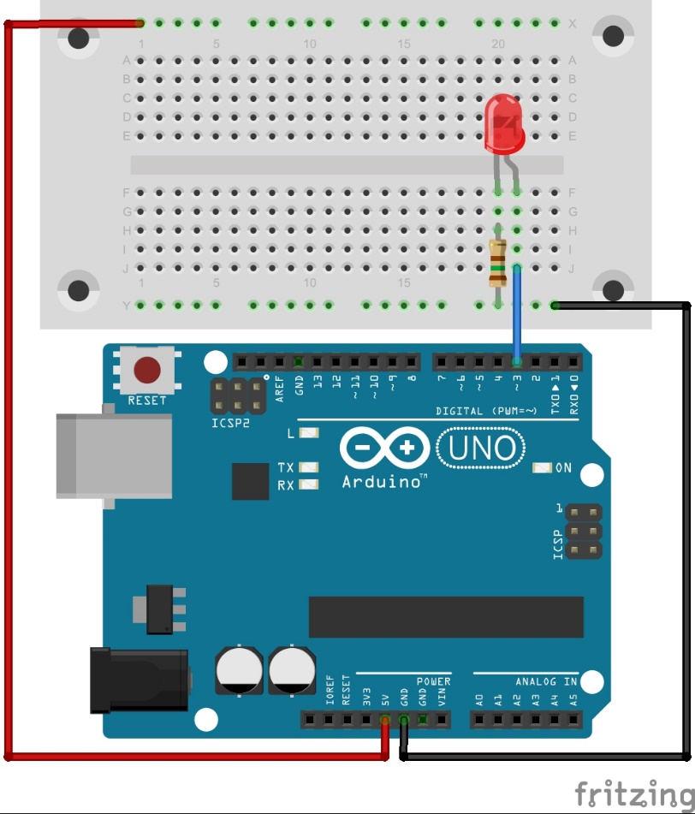

The code

int LEDPin = 3; //variable storing pin number the LED is attached to

void setup(){
pinMode(LEDPin, OUTPUT); //Set the pin the LED is attached to as an output
}//end of: setup

void loop(){
digitalWrite(LEDPin, HIGH); //Bring the LEDPin high to turn on the LED
delay(1000); //Pause for 1000 milliseconds (1s)
digitalWrite(LEDPin, LOW); //Bring the LEDPin low to turn off the LED
delay(1000); //Pause for 1000 milliseconds (1s)
}//end of: loop

What next
- Change the code so the LED is on for 2 seconds and off for half a second
- Turn the LED on at the start and get it to stay on perminantly

