02 Digital Read

The circuit

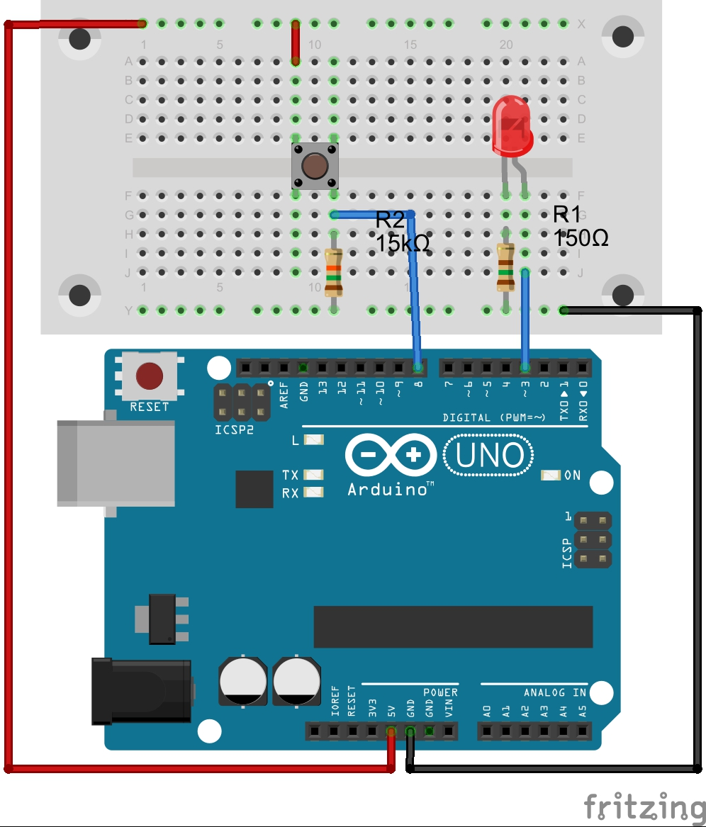

The code
int LEDPin = 3; //variable storing pin number the LED is attached to
int buttonPin = 8; //variable storing pin number the button is attached to

boolean buttonState = LOW; //a variable to store the state of the button

void setup(){
pinMode(LEDPin, OUTPUT);//Set the pin the LED is attached to as an output
pinMode(buttonPin, INPUT);//Set the pin the button is attached to as an input
}//end of: setup

void loop(){
buttonState = digitalRead(buttonPin); //Read the state of the button and store it in

//the buttonState variable

if(buttonState == HIGH){ //See if the button state is hig (pressed)
digitalWrite(LEDPin, HIGH); //Bring the LEDPin high to turn on the LED
}
else{ //otherwise the button is not being pressed
digitalWrite(LEDPin, LOW); //Bring the LEDPin low to turn off the LED
}
delay(100); //Pause for 100 milliseconds (0.1s)
}//end of: loop

What Next?
- Connect a piezo buzzer to one of the digital pins and get it to play a tone when the button is pushed (have a look at ‘Help-Reference’ for tone to find out how it works. Here is the syntax you need: tone(pin, frequency, duration); )
- Now you have one button playing one tone… try adding another button and get it to play a different tone (you can use the same piezo buzzer)
- Maybe it would be better if you starting playing a tone without a specified duration using: tone(pin, frequency);, you could then use noTone(pin); when the button is released

- A concept called button bounce can be an issue. Find out what it is and look at ways you can overcome it with hardware (electrical components) and software (code)

