04 Analog Read

The circuit

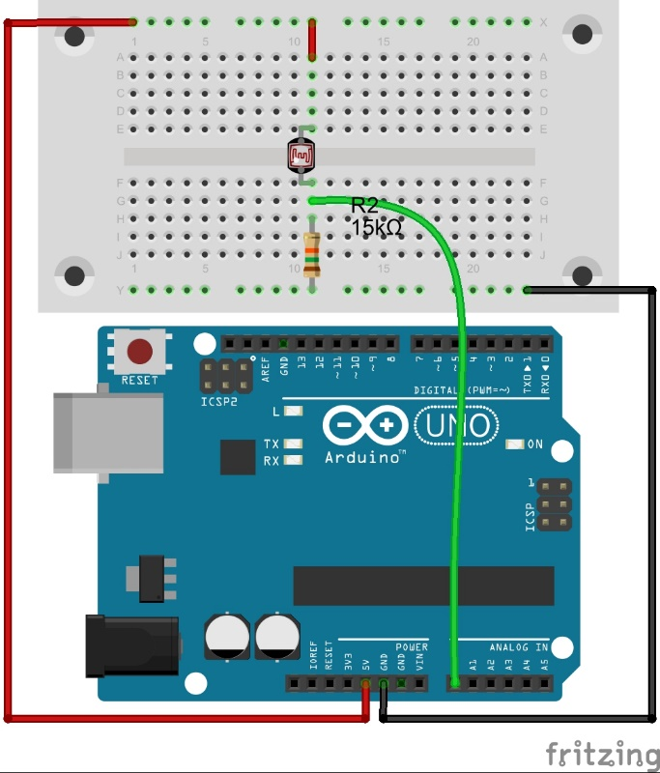

The code
int LDRPin = A0; //variable storing pin number the LDR potential devider is attached to

int brightness = 0; //variable to store the brightness measured from the LDR potential divider
float voltage = 0; //variable to store the calculated voltage at the LDR pin

void setup(){
pinMode(LDRPin, INPUT); //Set the pin the button is attached to as an input

Serial.begin(9600); //Start serial communication at 9600 baud rate
}//end of: setup

void loop(){
//Read the analog value at the LDR pin
//The value will be between 0 at 0V and 1023 at 5V
brightness = analogRead(LDRPin);
delay(100); //Pause for 100 milliseconds (0.1s)

//Calculate what the voltage must be
//deviding 5 by 1023 gives use the voltage increment = 0.00489 V/inc
//multiplying by brightness, or the total number of increments
//gives the voltage
voltage = (5.0/1023) * brightness;

//Print some information to the user
Serial.print("Brightness = ");
Serial.print(brightness);
Serial.print("\t Voltage = ");
Serial.println(voltage);
}//end of: loop

What Next
- Read in the value of more than one LDR potential divider (say three like the ones on your line sensing robot) and print the values. See what happens to the values if you move the sensors over light and dark surfaces
- Use the tone() command and a piezo buzzer (+ 100Ω series current limiting resistor) to play a certain frequency tone based on the light falling on an LDR…
- Rock out

